**Osborne School Newsletter**

**Upcoming Events: November 2018**

**Thurs., November 8** – Remembrance Day Assembly: 9:30 a.m.

**Mon., November. 9 - 12** – No School

**Tues., November 13** – Picture Retakes @ 11 a.m.

**Tues., November 13 –** Jacob Moon - School Presenter “Listen to Your Passion”

**Wed., November 14 –** Co-Op Gift card fundraiser begins.

**Fri., November 16 –** Report cards go home

**Fri., November 16 –** Grades’ 5 – 8 fun swim 9 - 10

**Sunday, November 18 –** SCC Trade Show and Sale 12 – 5:00 pm

**Thurs., November 22 –** Co-Op Fundraiser ends

**Thurs., November 22** – Parent Teacher interviews 3:30 – 8:30, Scholastic Book Fair 3:30 – 6:00.

**Fri., November 23 –** Gr. 7/8 class volunteers at Pineview Senior Lodge 10 – 11:30

**Mon., November 26 –** SCC meeting @ 5:30

**Wed., November 28 –** Mad Hatter’s production of “Cinderella” a.m.

**Fri., November 30** – “Mary Poppins” at the E.A. Rawlinson Centre a.m.

[](http://www.google.ca/url?sa=i&rct=j&q=&esrc=s&source=images&cd=&cad=rja&uact=8&ved=0CAcQjRw&url=http://grandave.dsbn.org/PrincipalsMessage.html&ei=FZRSVOLNFIuuyQS7kYCYCg&bvm=bv.78597519,d.aWw&psig=AFQjCNHbyie-J02i9TUrr-ktKSIMNplIiA&ust=1414784250314473)

As you know, Osborne School is working on a reading comprehension goal this year. Take some time to talk with your child about the personal goal that they have set for their reading this year. Ask them about the “Challenge Yourself” Bulletin board in the hallway at school. Inquire as to which reading strategies they have used so far this year. You may be surprised at how well your child can articulate their current reading situation and how they plan to become better readers!

**Ideas to get involved in reading!**

1. Attend a parent-teacher conference. You’ll discover how your child is doing in reading and other subjects. You may also see books he/she is reading and samples of writing.

2. Visit the school book fair. (Open for viewing during interview night). You and your youngster will enjoy browsing new books, usually offered at discounted prices.

3. Check out your child’s seesaw account. Listen to a sample of their reading.

A huge thank-you to the parents/guardians who re-sided the community shed and did the skate shack repairs. We are ready for the Osborne skating season to begin.

We would also like to thank our school community council, staff and students who all came together to make the Harvest Dinner such a huge success. We had a wonderful turnout and it was great to see so many community members attend. Thank you so much to all the parents and guardians who volunteered and helped make this dinner such a huge success!

November is a busy month with fundraising! Our co-op cards will be on sale from Nov. 14-22. Our beef ticket sales will continue on until Dec. 19. The winners will be drawn at the Christmas concert. You DO NOT need to be in attendance to win. Some amazing prizes are up for grabs to our top ticket sellers including two very fancy BMX bikes. Thanks to Canadian Tire. Again, we would like to acknowledge Wayne & Debbie Acorn for donating the 150 lbs of beef cut & wrapped and Joey & Christine Christian for donating a wide tire mountain bike for the Osborne School Raffle.

**SCHOOL NEWS**

**News from the grade 7/8 Student Leadership Crew(SLC)**

Last week we had our WE SCARE HUNGER food drive contest.  We did a challenge of girls vs. the boys and the girls took the lead with 262 items and the boys brought in 212 items for a grand total of 474 items. Congratulations! Isn’t that amazing?!!!  Thank you staff, students, and families for supporting this important local cause.

What great school spirit Osborne staff and students have! What a fun Monster Mash Sock Hop on the 31st.  The grades 5 – 8 put their newly learned dancing lessons into good use. Everyone sure enjoyed themselves!

Our next spirit day is on **Thursday, November 8th**.  Be sure to dress in red, white, and black to show your Canadian Pride at our Remembrance Day assembly. Stay tuned for our Remembrance Day colouring contest.

**Ticket Sale:**

[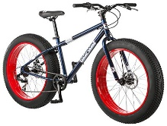](https://www.google.ca/url?sa=i&rct=j&q=&esrc=s&source=images&cd=&cad=rja&uact=8&ved=2ahUKEwicupnZmKzeAhVkHDQIHSSiCy4QjRx6BAgBEAU&url=https://www.amazon.com/Mongoose-Dolomite-wheel-Mountain-Bicycle/dp/B01KHE621E&psig=AOvVaw2B1nrzFODb9tMnR8jMUXFh&ust=1540921123689402)[](https://www.google.ca/url?sa=i&rct=j&q=&esrc=s&source=images&cd=&cad=rja&uact=8&ved=2ahUKEwjHireXmKzeAhX3FjQIHYWyAlQQjRx6BAgBEAU&url=https://www.telegraph.co.uk/news/worldnews/europe/germany/10095976/Germany-drops-its-longest-word-Rindfleischeti....html&psig=AOvVaw0meG3ONsv7iIj1rHkI-gWa&ust=1540920934147129)On Wednesday, December 19th Osborne School will be drawing the winners of our amazing prizes at our Christmas concert. 1st prize - 150 lbs of beef (cut & wrapped) 2nd prize – wide tire mountain bike.

Thank you to all the students and parents who are working so hard to get those tickets sold, good job everyone!

Every student from K-8 who sells tickets will take home a prize.

**Grades 5 - 8 Volleyball:**

Thank you to coaches, Mrs. Christian, Miss Sonen and Mr. Fiddler for all their time spent practicing with the volleyball teams. The 7/8 volleyball extravaganza is this week. Good luck students!

The 5/6 volleyball team has finished for the year, they had a great season and learned many new skills.

**Basketball:**

Boys and girls basketball practices will be starting up soon.

**Hot Lunch:**

C:\Users\vfrantik\AppData\Local\Microsoft\Windows\Temporary Internet Files\Content.IE5\UBGKRX2V\MC900060286[1].wmfWe have started up the hot lunch program again this year, which will be supplied to us by Boston Pizza and Mildred Everest. We will continue to have them approximately every two weeks. Notes will go home the week before as they have to be returned to the office by the Tuesday before hot lunch in order for Boston Pizza to get the order to us on time. Mrs. Everest requires the number of orders a week a head of time, so please remember if you are ordering your orders need to be in early.

**Remembrance Day Assembly:**

**C:\Users\vfrantik\AppData\Local\Microsoft\Windows\Temporary Internet Files\Content.IE5\2URN32QD\MC900326850[1].wmf**On Thursday, November 8 at 9:30 a.m. all classes will gather in the gym to pay respect for the sacrifices made by our fellow Canadians, some of which were family members, friends and neighbors. Students have been asked to wear red and black or white to support our Canadian Veterans. All parents/guardians are welcome to attend.

**School Community Council Presents A Christmas Shopping Extravaganza**

The School Community Council will be hosting a Christmas shopping extravaganza at the school on Sunday, November 18th, from 12 – 5 p.m. Please encourage family, friends and community members to come and check out this awesome event.

**Report Cards and Parent Teacher/Student Interviews:**

C:\Users\vfrantik\AppData\Local\Microsoft\Windows\Temporary Internet Files\Content.IE5\2URN32QD\MC910217623[1].wmfReport cards will go home on Friday, November 16. Parent Teacher/student Interviews will be held Thursday, November 22 from 3:30 to 8:30 p.m. The scheduled interview times will be sent home with your child’s report card. Our parent teacher/student interviews are very important for good communication with home and school.

**Scholastic Book Fair:**

We are very excited to be holding a scholastic book fair in the Library. The books will be here starting November 19 for the week and will be here for parents to view during parent/teacher interviews from 3:30 to 6:00. This is a great opportunity to get some Christmas shopping done!

**Bus Travel:**

C:\Users\vfrantik\AppData\Local\Microsoft\Windows\Temporary Internet Files\Content.IE5\4EXLHZN9\MC900410867[1].wmfA reminder to parents/guardians, students must have a note when they are to go on a different bus than their own. Please indicate where they are going, the date and your signature. Your cooperation with this is appreciated. BUS SAFETY IS EXTREMELY IMPORTANT! PLEASE REMIND STUDENTS TO STAY SEATED AT ALL TIMES.

Also as a reminder when you see a bus stopped with their lights flashing PLEASE stop for the safety of our students.

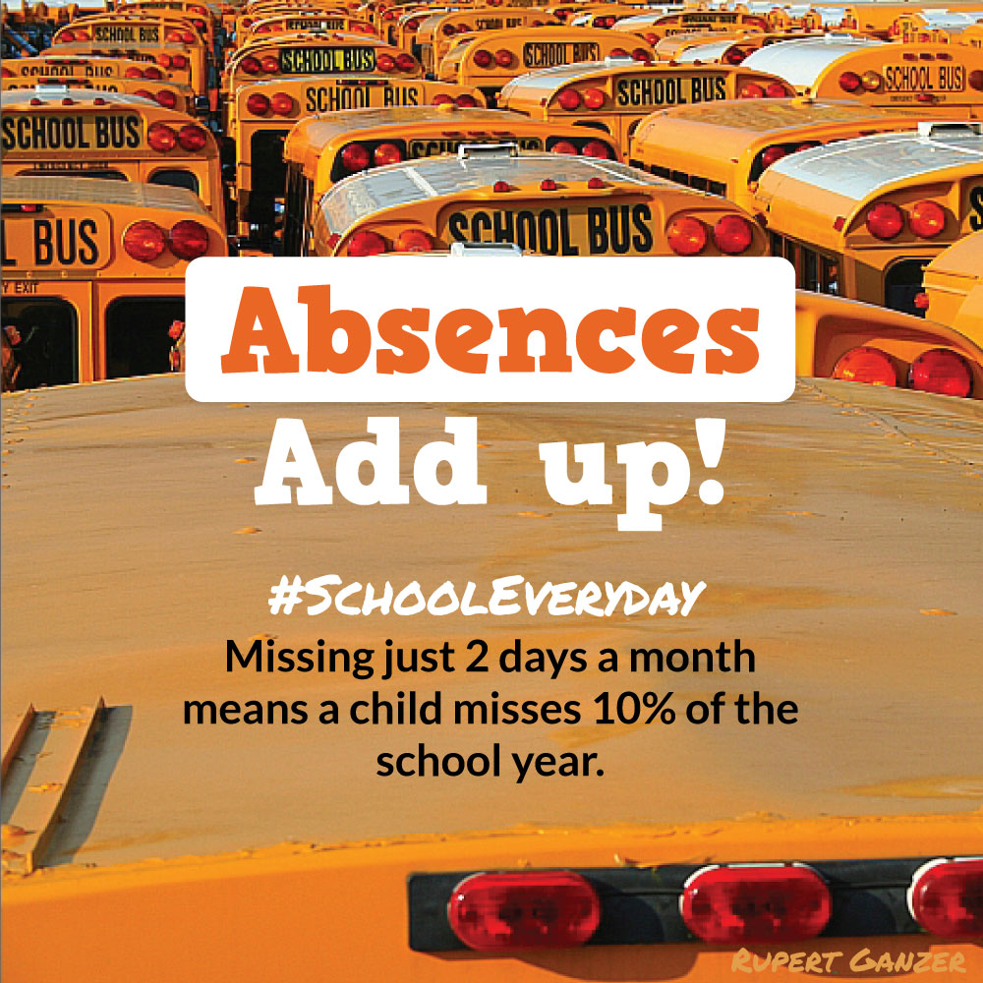

**Community News:**

Interested in Fitness Classes??

The Osborne Recreational Board is looking to offer an Adult Light Fitness Class.  This would be held at Osborne School starting mid January 2019 on Tuesday evenings, with the tentative times being 5:30 or 6:00pm. Classes will be 50 minutes long and run for approximately six weeks.

Please contact Laura Olson @ 306-960-8744 or Val at Osborne School Office @ 306-922-8078 if you are interested.



The Mad Hatter Theatre Company proudly presents the classic tale of Cinderella at the E.A. Rawlinson Centre on Sunday, November 18 at 2pm. Tickets are available from the box office both online and at the centre. This interactive family entertainment production follows the Prince in his quest for his one true love. Children of all ages and the young at heart will enjoy the antics of the characters in this light hearted rendition of the story. Return to the innocent world of childhood literature as the story comes alive on the stage. We invite you to sit back and enjoy an interactive fairy tale world of pumpkins, grumpy step sisters and romantic love!



**PA Athletics Track Club**

**Registration Night**

Thursday November 13 & 15th, 6:00 – 7:30 pm

Alfred Jenkins Fieldhouse 3rd Floor, All ages welcome

Registration fee - $300.00, RJT Plus fee $175 (10 – 14)

Run/Jump/Throw - $100.00 (9-12yrs)

For more information visit [www.paathletics.ca](http://www.paathletics.ca) or our facebook page at pa athletics







**East Central Public School**

**Christmas Craft & Bake Sale**

**Saturday, December 1st**

**10:00 to 4:00**

**10 minutes east of Prince Albert on Highway 302**

**Scentsy, 31 Bags, Epicure, Sturdy Furniture Co.,Cotton Candy Kids, Happy Hippo, Custom Made Wooden Signs, Togara Jewelry & Nygard Clothing, Norwex,**

**Young Living Oils, P.A. Branch of Navy League, Partylite, Constantly Beading & Baking, Tiber River Naturals, Art Work, Sewing, Knitting & Honey,Tarot Card Reading, Jewelry, Woodwork & Carving, Mala Bracelets & Necklaces, Calendars**

**East Central Public School Jewelry Making Club**

**Mermaid Blankets, Dragon Tales, Pillow Blankets & Mitts**

**Aromatherapy Blends, Baby Balms, Face Serum, & Homemade Soups**

**Cherise from Results Laser & Cosmetic Therapy Clinic**

**And much, much more!**

**There will be a canteen on site as well!**



